DIY Innovation Day

# Build your project in a day.

# Imagine Cup Junior Build your Project in a Day kit.

We want to make sure Imagine Cup Junior is open to as many students as possible. If you don’t have time to deliver the full module content, we have designed a workshop you can run with your students to help them develop and prototype their projects. With this document we’ll help you be more:

* **Confident** in running an Imagine Cup Junior building session   
  with your students.
* **Prepared** to move through the activities in a one-day Hackathon.

# Your DIY Hackathon pack includes:

## This Hackathon preparation and script guidance document

Included in this document are preparation guidance to set up your students for success and PowerPoint slide overviews and details on what to cover with your students in each section of the PowerPoint presentation

## Video and slide deck

We’ve created a PowerPoint deck for you with embedded videos that introduces your students to members of the Microsoft Worldwide Education and AI Teams.

## Core learning (3-6 hours)

The kit has been designed to be delivered over a period of 3 - 6 hours depending on the amount of content you decide to use. Throughout the day you can refer to content in the core modules, which includes lessons on:

* What AI is,
* Ethical considerations of this technology,
* How it can be used for good, and
* Opportunities for design-thinking sessions.

This pack supports you with and understanding the PowerPoint deck slides and leading activities. Please get social when you are running your sessions! Tweet @MicrosoftEdu using: #MicrosoftEDU

Using the Build your Imagine Cup Junior Project PowerPoint deck.

**Slides 1-8:** This is how you can begin your day with some values, as well as important information about the challenge.

**Slides 9-11:** Use this section to teach your students about AI.

**Slides** **12-14:** Ethics will form an integral part of the projects your students will create. In this section your students can learn about the Microsoft AI ethical principles and begin to think about their own AI ideas.

**Slides** **15-19:** Key dates for the Imagine Cup Junior, challenge guidelines, and judging criteria.

**Slides** **20-39:** Help your students decide on the area in which they want to make a difference. Have them choose from AI for Earth, AI for Health, AI for Humanitarian Action, AI for Cultural Heritage, or AI for Accessibility.

**Slides** **40-53:** Students then examine in depth the problem they have identified to get a better understanding.

**Slides** **54-66:** It’s time to innovate. These slides suggest approaches your students can take to help them solve the “how can we” question.

**Slides** **67-80:** Your students will be selecting their final idea at this stage and working together to develop and perfect their concept.

**Slides** **81-91:** To maintain a focus on ethics, these slides include some closing activities to help your students improve their ethics score.

**Slides** **92-106:** Submission time. A reminder to students of the judging criteria, what to prepare and submit to their educators, and some educator-only slides for more information on how to submit your students’ projects.

Activities.

Here are some notes on how you can run your innovation day and some activities you can try:

# Setting up the day.

## PowerPoint slides 1-8

We recommend putting aside between three to six hours to run the DIY Hackathon. This gives you time to explain to students the important foundational information, help them find innovative solutions for their problem, and even submit their project on the same day.

You will need a room that can accommodate all of the students, a table for each team, equipment to display the presentation, and speakers to play the embedded videos.

For the innovation section, you will also need pens, paper, and sticky notes.

You can use slides 1-8 to position the purpose of the day and share more on Imagine Cup Junior.

# What is AI?

## PowerPoint slides 9-11

We open this section with some definitions and a bit of AI history to help students understand what it is that they are supposed to be innovating. You can also use some of the slides within Lesson 2 “What is AI” to assist in giving your students a foundation in AI.

# The ethics of AI.

## PowerPoint slides 12-14

It is important to use this section to help your students understand the ethics behind the technology. This section includes a video from Dan Morris, a Principle Scientist for Microsoft, who runs the Microsoft AI for Earth program. Please refer to Core Module 1 to support with learning on ethics.

# AI for good.

## PowerPoint slides 20-42

This is where your students will be exposed to the challenge areas that they wish to make a difference in. For this project, they can choose from **AI for Earth, AI for Health, AI for Humanitarian Action, AI for Cultural Heritage, or AI for Accessibility.** We suggest stepping through the slides on each category with your students after which they can form their teams based on within which sector they would like to solve a challenging problem. In each team complete the simple sentence, “It is unacceptable that...”. They need to complete this sentence in reference to their chosen ‘AI for….’ area, and to a problem they are keen to solve as they move through the challenge.

# Understanding their problem - the root cause tree.

## PowerPoint slides 43-56

At this stage of the challenge the students will have identified a challenge in the sector that they are passionate about.

It is likely their problem areas are broad, such as “climate change” or “plastic in the ocean”. What we want them to do now is to drill down into their problem to become far more specific. We introduce the root cause tree to assist them in working through and get to the root of what they want to solve. Students can either draw their own trees or use the template that we have included in this document.

# The root cause tree

Students begin by writing the problem they have identified into the trunk. You can see our example here:

Next, it is time to ask why the problem is happening. In the five main roots of the tree, students should write the **five main reasons** why they believe the problem occurs. For example:

The next step is to keep expanding the roots to try to capture more reasons. Keep the students continually asking **“why”**? For example:

With the information they have now collected, rather than trying to solve the broad problem in the trunk of the tree, your students should select **just one root** as the specific problem they would like to solve with AI.

Root cause tree template



The problem…

# Innovating solutions.

## PowerPoint slides 57-69

At the start of this section, make sure each team has developed their own clear “How can we” question. A “How can we” question is a commonly used tool in problem-solving, and it forces inventors and creatives to focus on a very specific challenge in order to come up with their solutions.

Once they have their “How can we” questions, they can then begin work in their teams to develop solutions. We discuss this in the video. But to recap:

**Keep innovating until you have come up with lots of ideas to solve your “How can we” question. In fact, we don’t think you should stop until you have come up with fifty ideas. And before you say, “That will take months to do!”, know that the fastest innovating teams can usually get to hundred ideas in about twenty minutes.**

Practically, here is how your students should rapidly create fifty ideas.

* Get everyone standing up with a handful of sticky notes each and some pens.
* Play some music. Music without vocals is best, as it doesn’t distract.
* Someone should clearly state the “How can we” question the group is focusing on.
* Share the innovating! Every time someone has an idea, they should write it on a sticky note or a piece of paper, and then say it out loud as they put it down in the middle of the table, or on a wall.

## There are no bad ideas

Encourage your students to be brave and bold with their ideas and find ways to support and celebrate each other’s suggestions. These ideas can be as innovative as they like. Let them use their imagination and think big! By encouraging the most unique and unusual ideas, the likelihood is they could stumble upon something pretty great that is less likely to be duplicated. Creativity and collaboration are important tools for reaching the goal of fifty possible solutions.

## Work as a team

Make sure the teams are inclusive of all members and open to everyone’s suggestions! Diverse ideas are what will make the project great. Ensure that the students welcome each other’s opinions, experiences and differences in developing an idea that is well thought out.

# Other innovation activities.

In the slides we have a few other ways your students can innovatively create more ideas.

We encourage teams to go around the room asking their ‘How can we’ question to other people to extract seeds of more ideas from them. We recommend doing this for about seven minutes and making it as fast paced as possible.

The final activity we recommend is quiet ideation, where everyone quietly and independently comes up with more ideas. This is a great one for the more introverted students.

Picking the best ideas and making it better.

# The persona prototype

Your students now need to select their best idea from the list of potential solutions they created earlier. In this activity you can help your students create their persona prototype and improve their ideas.

**Step 1:** Start by inventing a persona, giving them a name and draw them. The persona you invent might be a possible user of your AI idea. You can see our character below, Grandpa Joe and Grandma Mary



**Step 2:** Explain a little bit about a problem that the persona is facing.

Grandpa Joe and Grandma Mary live in a large town with plenty of friends and a large family. They like their independence but keep forgetting simple things like when to take their medicine, the names of people they know, grandchildren’s ages and birthdays, their shopping lists and a few other things. This is really embarrassing for them sometimes so can you help them?

**Step 3:** We then explain how the AI idea we have is going to help our persona.

The Solution:

Meet Bobby. Bobby is a virtual ‘Grandson’ created to help Joe and Mary overcome some of the problems they face. With Bobby they can use the camera on their phone to point at a face and it will tell them who they are and will remind them not only to take their pills, but also when they need to go to the doctor to get more. As Joe and Mary have difficulty using the tiny keyboard on their phone Bobby has big colourful icons and can even be voice activated by either Joe or Mary.

**Step 4:** Have your students present their persona prototypes to other teams and ask for feedback in the form of “I like” or “I wish”, based on what they like about the idea, and what they wished we did differently. All the feedback students gain from these conversations can then be put into improving the idea!

The Outcome:

With Bobby’s help Joe and Mary are now no longer worried that they may forget the name of people they meet, or forget to take their pills on time, or how old their grandchildren are, or when it’s their birthday.

In fact, they are really happy to have Bobby’s help and feel even more independent.

Ethics check-in.

## PowerPoint slides 84-94

Ethics are a critical consideration for your students’ project. At this stage they should be assessing the system they have come up with against the following criteria:

* **Fairness:** AI systems should treat all people fairly.
* **Inclusiveness:** AI systems should empower everyone and engage people.
* **Reliability & Safety:** AI systems should perform reliably and safely.
* **Privacy & Security:** AI systems should be secure and respect privacy.
* **Transparency:** AI systems’ real goals should be clear.
* **Accountability:** AI systems should be accountable to other humans not just its inventor.

In their final submission students will need to include a sentence or two on each of these points in the form of:

**“We believe our AI idea is fair/inclusive/reliable & safe/transparent/private & secure and accountable because...”**

Students need to make a strong case that their idea is touching on these ethical principles in a meaningful way. It’s a great opportunity for them to rethink some components of their idea, and add in ways to make it safer, fairer and more transparent.

If you have the time, encourage your teams to review each other’s ideas and give an ethical score.

Make sure that all the student teams are reminded of the Microsoft ethical principles, and then have them score the ethics of another team’s idea on a scale of 1 to 3 for each ethical pillar. This can be a great way for them to step-back from their ideas, and engage more powerfully with the ethical principles, while at the same time gaining feedback on their own submissions.

Submission time.

## PowerPoint slides 95-102

Please review the submission requirements and judging criteria in order to ensure students projects are compliant. Add how you would like your students to submit their project to the lead educator – email/Teams/SharePoint etc.

Refer to the educator-only slides for guidance on how you can submit your students’ projects at [Imagine Cup Junior 2022 | Imagine Cup (microsoft.com)](https://imaginecup.microsoft.com/en-us/junior).

Stretch projects

## PowerPoint slides 103-105

To get started with your stretch challenge, educators can download the guide at [www.imaginecup.com/junior](http://www.imaginecup.com/junior)

## PowerPoint slide 106: Introduction to Minecraft

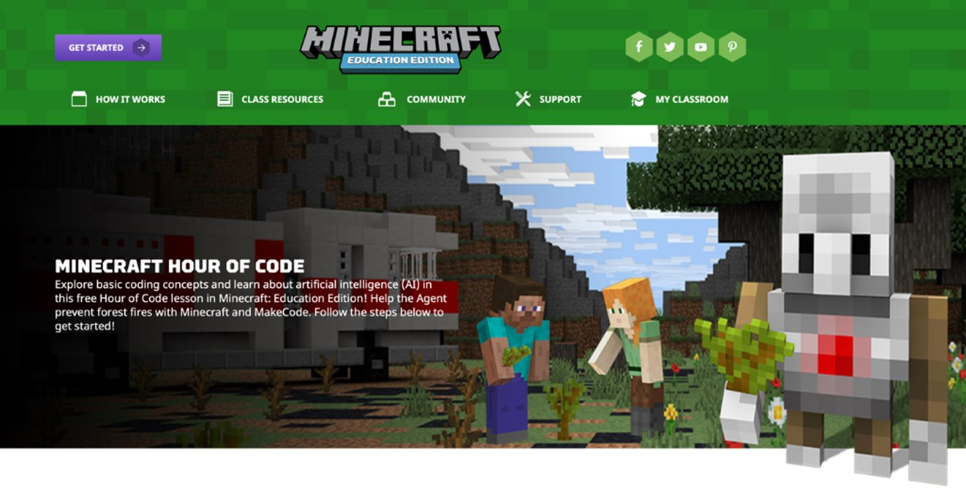

Explore basic coding concepts and learn about artificial intelligence (AI) in this free Hour of Code lesson in Minecraft: Education Edition! Help the Agent prevent forest fires with Minecraft and MakeCode. ​

​

The course with full instructions can be found on this link: ​

<https://education.minecraft.net/hour-of-code>   ​

​

